Create acount on stripe

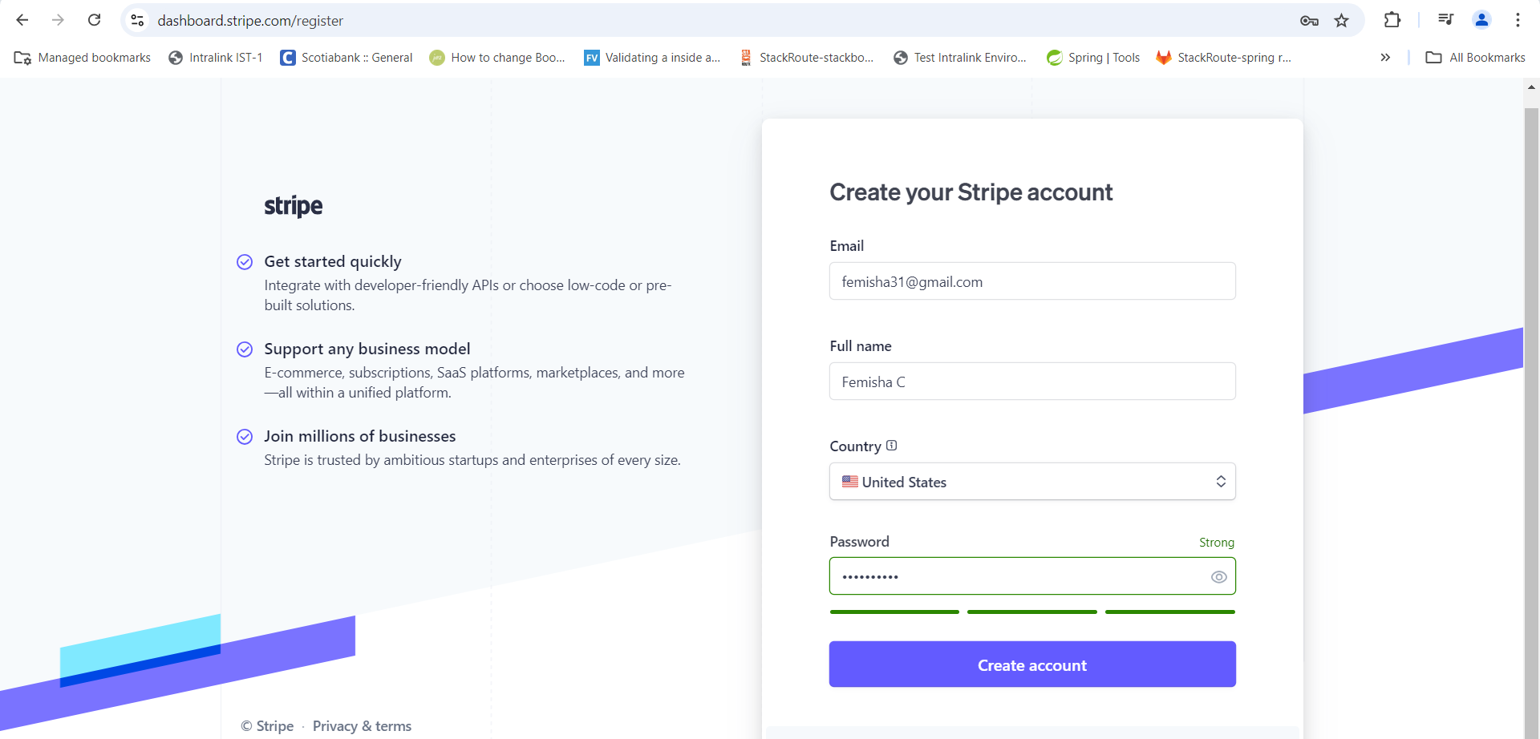

Once verified email, login to stripe test dashboard.

<https://dashboard.stripe.com/test>

Click on Developer and select API Keys option

Use this secret key to access stripe API in code

Use this secret key to access.

Once completed, Run this application.

Payment link will be generated.

Use this payment link to make payment thru Stripe

Use test cards available in stripe website to make this payment.

Give test card details and some dummy data.

Once payment successful, it will be redirected to REDIRECT URL, which we specified in our code.

We gave google.com

If we want, we can also pass some reference id in URL.

We can also see payment status in stripe dashboard

We can also refund from this stripe dashboard.

